school uniforms | book bags |  | hygiene materials |  | Supplies

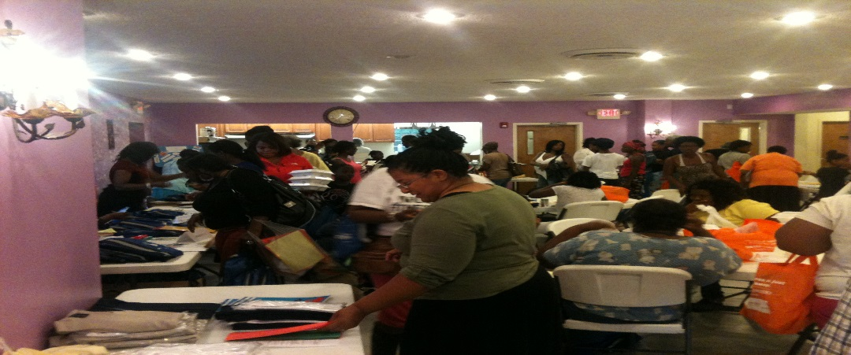
Back to School Giveaway

2 |  | August |  | 2-5 PM
Shiloh Temple |  | 1178 E. 79th St., Cleveland, OH  Disclaimer: If we are unable to gather due to social distancing, please select a time you would be able to come and pick up materials for your child (ren). Call (216) 881-2979 or go to www.shiloh-temple.org and click on Back To School.
